**CONTENT:**

**Recruitment & Selection:** Recruitment, factors affecting recruitment, sources of recruitment, Selection – Process, selection test, Interview, Orientation, and Placement.

**Training & Development:** Training- Objectives & Importance of training, Training Methods- On job training and off- the job training

**OUTCOME:**

After studying the unit on Recruitment & Selection, individuals will gain a comprehensive understanding of recruitment factors, various sources, and the selection process including tests and interviews. Additionally, they will be familiar with orientation and placement procedures.

In the context of Training & Development, learners will acquire insights into the objectives and importance of training. They will also grasp different training methods, such as on-the-job and off-the-job training.

**RECRUITMENT:**

* Recruitment refers to the process of identifying, attracting, interviewing, selecting, hiring and on-boarding employees.
* In other words, it involves everything from the identification of a staffing need to filling it.
* **Recruitment** is [the overall process](https://en.wikipedia.org/wiki/Recruitment#Process) of identifying, sourcing, screening, short-listing, and interviewing candidates for [jobs](https://en.wikipedia.org/wiki/Job_(role)) (either permanent or temporary) within an [organization](https://en.wikipedia.org/wiki/Organization).
* Recruitment is the process of actively seeking out, finding and hiring candidates for a specific position or job.
* The recruitment definition includes the entire hiring process, from inception to the individual recruit’s integration into the company.
* Recruitment is a positive process of searching for prospective employees and stimulating them to apply for the jobs in the organisation. When more persons apply for jobs then there will be a scope for recruiting better persons.
* Recruitment is the process of finding and attracting qualified individuals to apply for job positions within an organization.
* Recruitment is the end-to-end process of effectively and efficiently sourcing, screening, selecting, and appointing the best-suited candidate to the right role.

**DIFFERENT DEFINITION BY DIFFERENT AUTHORS:**

**According to Edwin B. Flippo:**

Recruitment is "the process of searching for prospective employees and stimulating them to apply for jobs in the organization."

**According to Yoder:**

Recruitment is "a process to discover the sources of manpower to meet the requirements of the staffing schedule and to employ effective measures for attracting that manpower in adequate numbers to facilitate effective selection of an efficient workforce."

**According to Louis A. Allen:**

Recruitment is "the process of locating, identifying, and attracting capable applicants."

**According to Flippo:**

Recruitment is "the process of searching for prospective employees and stimulating them to apply for jobs in an organization."

**According to Decenzo and Robbins:**

Recruitment is "the process of attracting individuals on a timely basis, in sufficient numbers and with appropriate qualifications, and encouraging them to apply for jobs with an organization."

**PROCESS OF RECRUITMENT:**

* A recruitment process involves activities like identifying different sources of labour supply from which applications of prospective employees may be obtained; evaluating the validity of different sources; choosing the most suitable source; and attracting and motivating prospective candidates to apply for the vacant jobs.
* Every organization follows its own recruitment process, but there are some basic steps that are followed by most the organization, which are listed here:

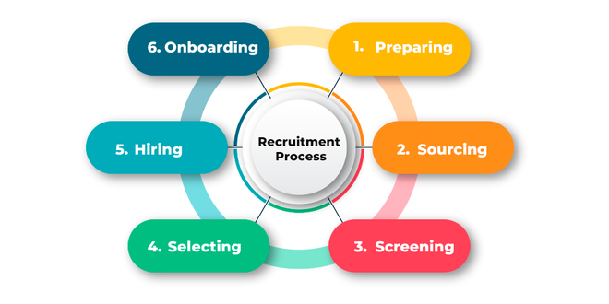

**Step 1: Preparing**

* Once the job opening is approved internally, the recruiter contacts the hiring manager. This step is about gathering details about the open position.
* During the discussion, the recruiter has to gather information, like the required skills, roles, responsibilities, etc., and use this information to write a clear and inclusive Job description.
* Based on the job description, they can write the job posting.

**Step 2: Sourcing**

* Once the job description is ready, the next step is to start the sourcing.
* It refers to identifying and contacting qualified candidates rather than waiting for the candidate to apply for the position.
* The primary goal is to pull qualified candidates.
* A recruiter uses a variety of **job portals** to pull the resumes, but it is not essential that for every position, sourcing is required.
* In some cases, if there are a large number of applications, there may not be any need to source more candidates.

**Step 3: Screening**

* The Screening of a candidate can take place in many ways. Generally, the first step is Resume screening.
* If the resume meets the criteria required for the job opening, then the next step is the phone screening, in which, the recruiter can cover topics, like the candidate’s availability, current role, and responsibilities, current salary, salary expectations, Notice period, etc., and if he seems to be the right candidate, an organization can process further with his profile.

**Step 4: Selecting**

* This process is about sending the assignments, **psychometric tests** and scheduling interviews, participating in the interview process, and also keeping the hiring manager in the loop for the whole process.
* It is about maintaining a good relationship with the candidate and keeping the candidate updated about the interview feedback.

**Step 5: Hiring**

* This step includes the final discussion with the candidate about salary, joining date, etc.
* Once the joining date is confirmed, the offer letter is released. In some cases, this step also includes background checks.

**Step 6: On-boarding**

* Once the candidate has accepted the offer letter, the process is not over yet. This is where the pre-boarding period starts.
* This is the time between the joining date and when the offer letter was accepted.
* And it’s very important to be in touch with your candidate during this period to keep them engaged.
* If not done so, it can result in them joining another company.
* It also includes sharing the new hire’s email and other details with the team.
* Once the candidate starts the first day, it’s time to begin the on-boarding process.

**SOURCES OF RECRUITMENT:**

* Recruitment is performed to attract potential employees with the necessary qualifications and skills in the adequate number for the positions available in the organization.
* It searches available people for the job and invites them to apply for the job.
* The process of recruitment precedes the process of selection of the right candidate for the given positions in the organization.
* Recruitment seeks to attract suitable applicants to apply for available jobs.
* An organization can recruit employees from within or from outside.
* Therefore, the various recruitment sources available to an organization may be broadly divided into two categories:

1. **INTERNAL SOURCES.**
2. **EXTERNAL SOURCES.**

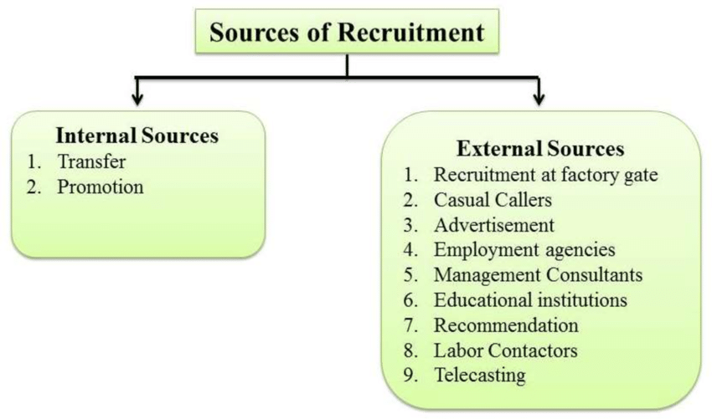

1. **INTERNAL SOURCES**

* Internal recruitment consists of two main resources that are transfers and promotions.

1. **Transfers:**

* Transfer refers to the moving of an employee from one job to another, one department to another, or from one shift to another without any significant change in a person’s responsibility, status, or pay.
* In some cases, it may bring about some changes in responsibilities, or working conditions, but it cannot result in a change in the salary of the employee.
* Transfer can help fill vacancies with employees from departments that are over-staffed. It is the horizontal movement of employees.
* If employees are insufficient in one branch or department, it can be filled through transfer.
* It is also important in avoiding termination and helping solve the employee’s problems.
* During the transfer, it should be kept in mind that the employee who is transferred to another job is capable of performing it.
* Transfer also helps the employees learn about different jobs as well.

1. **Promotions:**

* In most business organizations, there is a practice of promoting the employees from a lower level to a higher position.
* It is the movement of employees from a lower level to fill in the vacancy of a higher authority.
* Promotions influence the employees greatly as a promotion at one level leads to a chain of promotions in the levels lower than it.

**MERITS OF INTERNAL SOURCES**

* Internal recruitment or filling vacancies within the organization have the following advantages.

1. **Higher Motivation level:**

* Internal recruitment may help the employees to boost their performance.
* Promotions at a higher level lead to a chain of promotions at the lower levels.
* This also increases their status and pay, and motivates the employees to improve their performance.
* This increases their motivation and commitment to the organization.
* The employees, thus remain loyal and satisfied with the organization.

1. **Simple Process:**

* Internal recruitment makes the process of selection and placement simple.
* The working of the employees can be evaluated in a better way.
* This type of recruitment is better as the employees know about the organization well.

1. **Develops future managers:**

* Transfer is a method through which employees are trained for higher jobs.
* The people who are transferred within the organization do not need induction or orientation training.

1. **No over or under staffing:**

* Another benefit of transfers is that the organization can shift employees from one department to another where there is a shortage.

1. **Economical:**

* The process of internal recruitment is cheaper in comparison with external sources.

**DEMERITS OF INTERNAL SOURCES**

The limitations of internal sources are as follows:

1. **Lack of fresh talent:**

* The internal sources reduce the opportunity of getting fresh talents. Therefore, being completely dependent on internal sources can give rise to the danger of inbreeding by not letting new people join the organization.

1. **Decrease in enthusiasm level:**

* The employees tend to become lazy because they know that they will be promoted.

1. **Low productivity:**

* The productivity of the organization may get hampered due to the frequent transfer of employees.

1. **Lack of competition:**

* The employees may lose their motivation and spirit of competition as there is no competition from the outside world.

1. **Limited choice:**

* All the organizations cannot fill in all their vacancies through internal sources of recruitment, especially new organizations.

1. **EXTERNAL SOURCES**

* Since the filling up of all the vacancies in an organization is not possible through internal sources, there are several external forces for various positions.
* There might be a possibility that there are not sufficient men or that they do not fulfil the eligibility criteria for the job.
* The external sources of recruitment provide a vast range of choices and the introduction of fresh talents to the organization.
* The most used external sources are as follows-

1. **Direct Recruitment:**

* Under the process of direct recruitment, a notice is placed outside on the notice board of the organization.
* he notice contains all the details of the job available.
* The people who are interested gather outside the premises of the organization on the specified date and time, and selection is done then and there.
* This method of direct recruitment is usually used for finding candidates for unskilled or semi-skilled jobs.
* Such people are paid wages daily and are referred to as casual workers or ‘badli’ workers.
* This type of recruitment is economical, as it does not require any form of advertising and thus, a lot of money is saved.
* It can be really helpful in situations when there is a rush of work or when the permanent workers are off-duty.

1. **Casual Callers:**

* A lot of business organizations keep a record of uninvited job applicants in their offices.
* These candidates can be of benefit to the organization. Such a list of job-seekers can be evaluated, and used for filling up vacancies as required.
* This type of recruitment can decrease the price of recruiting the workforce.
* **Advertisement:**
* When a wide choice is required, advertisement is the frequently used method. Advertisements can be done through newspapers or trade or professional journals.
* A lot of senior positions in the industry as well as commerce are filled through advertisement.
* The benefit of advertisement is that a lot more detail about the organization and the job can be provided. It helps the management of the organization select from a larger range of candidates.
* Advertisements given in leading newspapers can bring in a lot of responses, but most of the time they are from candidates who are not quite suitable.

1. **Employment Exchange:**

* Government-run employment exchanges are considered a good source of recruitment for both skilled as well as unskilled jobs. In a few cases, the organizations are necessarily required to notify the employment exchange of vacancies available.
* Therefore, employment exchange work as a link between the job-seekers and the employers by matching the personnel demand and supply.
* But a lot of times, the records of employment exchange are not quite suitable, as they might not meet up the expectations of the job.

1. **Placement agencies and Management consultants:**

* Private agencies and professional bodies appear to be doing considerable work in technical and professional fields. Placement agencies help provide nationwide service by matching personnel demand and supply.
* These kinds of agencies evaluate the bio-data of several candidates and provide suitable names to their clients. T
* These types of agencies are useful where large-scale screening is necessary and they charge fees for such services.
* These professional agencies attract higher-level executives by providing the right kind of offers. Management consultancy firms facilitate the organizations to recruit technical, professional, and managerial personnel.
* They especially deal in middle and top-level executive placements.
* These firms manage huge sets of data people with different qualifications and skills, and also advertise jobs in the place of their clients to recruit the right person for the right job.

1. **Campus Recruitment:**

* Recruitments are also done through colleges and institutions of management and technology.
* These have become a significant source of recruitment for technical, professional, and managerial jobs.
* Several huge organizations keep close contact with universities, vocational schools, and management institutes to recruit qualified candidates for different kinds of jobs.
* Educational institutions are a widespread and normal practice for businesses for recruitment.

1. **Recommendations of Employees:**

* A lot of times, the present employees, or their friends or relatives may introduce applicants.
* This might be a good source of recruitment. Also, the background detail of the candidates is well known, so it is easier to select them.
* Some kind of introductory screening takes place because the employees working there know the company as well as the candidates, and therefore, would try to satisfy both of them.

1. **Labor Contractors:**

* Labor contractors are helpful as they keep close contact with laborers and in providing the necessary amount of unskilled workers in a short period.
* The labor contractors are themselves employees of the organization and perform the work of recruiting laborers whenever necessary.
* But if the same employee of the organization who is the labor contractor chooses to leave the organization, the laborers hired by him will also leave.

1. **Advertising on Television:**

* Proving advertisements on television is now becoming much more popular these days. It is attracting the attention of a large number of people.
* Also, whenever there is a vacancy, the job details and required skills regarding the job are posted along with the profile of the organization.

1. **Web Publishing:**

* The most common source of recruitment nowadays is the Internet.
* People can apply as well as post jobs through websites that are specially designed for this purpose.
* These websites are frequently visited by both candidates or job-seekers and organizations in search of required employees.

**MERITS OF EXTERNAL SOURCES**

Following are the advantages of the external sources of recruitment:

1. **Qualified Personnel:**

* With the help of external sources of recruitment, the management can get skilled and trained candidates who are qualified for that particular job which is vacant in the organization.

1. **Wider Choice:**

* When advertisements regarding vacancies are made widely, several applicants from outside the organization apply.
* Therefore, the management has a wide variety of choices.

1. **Fresh Talent:**

* Sometimes, the present employees in the organization may not be enough or able to fulfill the requirements of the organization.
* Therefore, external sources are very useful in bringing new and fresh talents to the organization.

1. **Competitive Spirit:**

* If an organization utilizes external sources, the existing employees will have to compete with outsiders.
* They will be motivated to work harder to perform better.

**DEMERITS OF EXTERNAL SOURCES**

Following are the disadvantages of the external sources of recruitment:

1. **Dissatisfaction among existing staff:**

* External recruitment may result in dissatisfaction and frustration among present employees.
* The employees may feel deprived of their chance to get a promotion.

1. **Lengthy process:**

* Recruitment from external sources follows long procedures and thus, can be time-taking.
* The organizations have to evaluate and give notice about any vacancy available, and then wait for the applications to be processed.

1. **Costly process:**

* The process of recruitment through external sources can be quite expensive.
* Advertisement and evaluation of applications for selection can be costly as a lot of money has to be spent.

**FACTORS AFFECTING RECRUITMENT:**

* [Recruitment](https://dynamicstudyhub.com/recruitment-meaning-definition-features-process-benefits-of-placement/) is an important aspect of any organization’s growth and success. Understanding the various factors affecting [recruitment](https://dynamicstudyhub.com/recruitment-meaning-definition-features-process-benefits-of-placement/) is essential for effective [workforce](https://dynamicstudyhub.com/workforce-diversity-definition-meaning-dimensions-factors-and-strategies/) [planning](https://dynamicstudyhub.com/planning-meaning-definition-nature-purpose/).
* In today’s dynamic and competitive job market, businesses must navigate a complex landscape shaped by economic, social, technological, and organizational factors.
* These factors play an important role in influencing how companies attract, select, and retain talent.
* By examining the key factors affecting recruitment, businesses can tailor their strategies to secure the best-fit candidates and build a skilled and diverse [workforce](https://dynamicstudyhub.com/workforce-diversity-definition-meaning-dimensions-factors-and-strategies/), ultimately contributing to their long-term prosperity.

Understanding the dynamics of these two factors is important for successful recruitment. The two factors given below have a major influence on recruitment. Effective recruitment necessitates a deep understanding of the impact of these two factors.

1. **EXTERNAL FACTORS**
2. **INTERNAL FACTORS**

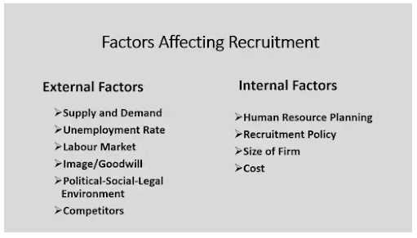

* 1. **EXTERNAL FACTORS**
* These factors or forces are these factors that cannot be controlled by the [organization](https://dynamicstudyhub.com/organization-meaning-definition-and-nature/).
* A variety of external factors which affect recruitment are as follows:

External factors affecting recruitment are given below:

1. **Supply and Demand**
2. **Unemployment Rate**
3. **Labour Market**
4. **Image/Goodwill**
5. **Political-Social-Legal Environment**
6. **Competitors**
7. **Supply and Demand**

* A significant factor in the recruitment process is the manpower supply, both inside and outside the organisation.
* If the demand for professionals in the company is more and the supply of professionals in the market is low, then the company will have to rely on internal sources for [training](https://dynamicstudyhub.com/training-definition-features-scope-need-purposes-of/) and developing employees.

**ii) Unemployment Rate**

* Growth of the economy is another factor that affects the availability of applicants, lack of jobs in the company and surplus labor in the market can give rise to a situation of [unemployment](https://en.wikipedia.org/wiki/Unemployment).

**iii) Labor Market**

* Employment conditions in the local area play a key role in the organization’s recruitment operations.
* Ordinary attempts like displaying job vacancies on notice boards or announcements in the official meetings, etc., will attract more than the needed candidates in case of excessive manpower at recruitment time.

**iv) Image/Goodwill**

* An employer’s image can also act as a hindrance to recruitment.
* The activities of the organization are the basis for building an organizational image.
* It becomes easier to attract and retain employees for an organization if it has a positive image and goodwill as an employer than an organization with a negative image.

**v) Political-Social-Legal Environment**

* Recruitment practices are directly influenced by various government regulations which keep out favouritism in [staffing](https://dynamicstudyhub.com/staffing-process-functions-importance/) and employment.
* **For example,** legislation for reservation in employment for scheduled castes, scheduled tribes, physically handicapped, etc., has been introduced by the government of India.

In addition, trade unions play a significant role in recruitment. This hampers the management’s freedom to choose potential candidates. Recruitment sources can be limited by the union’s regulations if the candidate does not fulfil the criteria set by the union.

**vi) Competitors**

* The recruitment function is also influenced by the recruitment [policies](https://dynamicstudyhub.com/what-are-policies/) of the competitors.
* Generally, organisations change their recruitment policies to match up with the competitor’s policies, so that they can compete in the market.
  1. **INTERNAL FACTORS**
* The factors that can be regulated by the organization itself are called internal factors.
* There are various internal factors in the organization which influence the recruitment programme.
* Internal factors affecting recruitment are given below:

1. [**Human Resource Planning**](https://dynamicstudyhub.com/meaning-nature-and-need-of-human-resource-planning-hrp/)
2. **Recruitment Policy**
3. **Size of Firm**
4. **Cost**
5. **Human Resource Planning**

* How many employees are to be recruited and what qualifications they should have is decided with the help of effective [human resource planning](https://dynamicstudyhub.com/scope-purpose-and-factors-influencing-human-resource-planning/).

1. **Recruitment Policy**

* The aims of recruitment are stated in the recruitment policy of the organization.
* It also gives an outline for the execution of the recruitment programme.

1. **Size of Firm**

* Another vital factor that affects the process of recruitment is the size of the organization.
* If the organization is planning to increase its operations and expand its business, it will plan to hire more employees to carry out its functions.

1. **Cost**

* Recruitment expenses are borne by the employer, therefore, organizations try to make use of that source of recruitment which gives more output at less cost.

**SELECTION:**

* Selection refers to the process of short-listing the applicants and selecting the best applicants who are suitable for that job position.
* It attempts to reject unsuitable candidates and select suitable candidates. So, it is considered a negative process/approach.
* It involves choosing the right candidate from the applications received.
* The main objective of selection is to get the best candidates selected for the job role.
* It follows recruitment, i.e., it is the final process that takes place after selection.
* It is a complicated process because it includes many steps and processes.
* It is an expensive method as a lot of money and time is required.
* After being selected for a particular job role, a contractual relationship for service is created.
* Selection refers to choosing the right candidate, who is most suitable for a job position that is vacant in an organization.
* It includes the process of interviewing the candidates and evaluating their skills, qualities, which are needed for a specific job.
* This is the process of selecting the appropriate candidate for the organization.
* It is a negative action because in this candidates are rejected and most suitable candidates are selected.
* Selection is the process of recognizing and choosing the best candidate out of several potential candidates for a job.
* The candidates who are not suitable for the job are eliminated. For selection, the candidates have to give several employment tests and interviews.
* At every step, many are shortlisted and some move on to the next round until the right candidate is found.
* The process of selection begins with going through the applications and continues even after the offer of employment, acceptance, and joining of the candidate.
* The reason for this is that the selection process is concerned with the evaluation of the employee’s performance potential, just like in any other function of management.

## DEFINITION OF SELECTION:

**According to Dale Yoder,**

“Selection is the process by which candidates for employment are divided into classes those who will be offered employment and those who will not.”

**According to David and Robbins,**

“Selection process is a managerial decision-making process to predict which job applicants will be successful if hired.”



**STEPS IN SELECTION PROCESS**

* 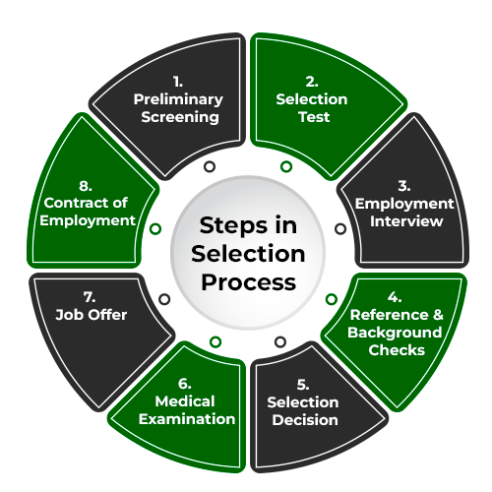The following are the important Steps in the Process of Selection:
  1. **Preliminary Screening:**
* Preliminary screening facilitates the manager of the organization to shortlist the candidates and eliminate those who are not suitable for the job based on the details mentioned in the application form.
* Preliminary interviews help avoid the unfit for reasons that did not emerge in the application forms.
* In this interview round, the candidates are questioned by the interviewer on account of their qualifications, experiences, etc.
  1. **Selection test:**
* This type of test is a method that is either a written test or an exercise that tries to find out some particular skill or ability of the employees either based on their mental ability, personality, physical capacity, or mindset.

Some of the important selection tests that are performed for the selection of employees are as follows:

* ***Intelligence test:****It refers to the measurement of one’s intelligence based on memory, reasoning, etc. It is an indicator of one’s ability to make decisions and judgments.*
* ***Aptitude test:****This test is taken to check if the candidate has the talent to learn new skills or the capability to grasp those skills that are needed to perform the specified job.*
* ***Personality test:****This test of the employee is conducted to understand the personal characteristics of the candidates, such as their values, mindset, patience, beliefs, etc.*
* ***Trade test:****It is a test to determine a candidate’s actual talents, i.e., they are given work according to their specified jobs. These tests are based on the employee’s level of knowledge and competency in the professional areas.*
* ***Interest test:****Every individual has their own set of interests or particular fields that they would like to work in. The interest test helps determine the candidate’s area of interest and the kind of job that would suit him. This ensures that the employees work with greater enthusiasm and efficiency.*
  1. **Employment interview:**
* An interview is a formal conversation between two people, i.e., the candidate and the interviewer. It is conducted to test the individual’s capability.
* The interviewer’s job is to question the candidate and obtain as much information as possible, and that of the interviewee is to provide the information with confidence.
* Though in the present time, the contrary is also seen.
  1. **Reference and Background Checks:**
* Personal details such as names, addresses, and telephone numbers of the references may also be requested to be provided to attain extra information about the candidates.
* The references can be anyone who knows the applicant, teachers, professors, ex-employers, etc.
  1. **Selection Decision:**
* The candidates who qualify for the tests, interview rounds, and reference checks ultimately get selected for the final decision.
* In this process, the opinion of concerned the manager makes the concluding decision as to who will be selected among those final candidates qualifying for that particular job.
  1. **Medical Examination:**
* After the selection decision and before the job offer is provided, the candidate goes through a medical examination to prove that they are physically and mentally fit for that job.
* Only then the candidate is given the job offer.
  1. **Job Offer:**
* The step following all the other steps is receiving the job offer. The job offer is provided to only those who have passed all the prior obstacles.
* The job offer is provided through a letter of appointment, which approves the candidate’s acceptance.
* The letter of appointment normally contains the date on which the candidate has to report on duty.
* The letter also prescribes a specified time at which the candidate is supposed to report.
  1. **Contract of Employment:**
* When the job offer is provided and accepted by the candidate, both the employer and the candidate are required to put into effect certain documents, like an attestation form.
* Such a form contains certain details that are verified and attested by the candidate. It is a document that may be beneficial in the future. It is also important to prepare a contract of employment.
* The information necessary to be written in the contract of employment may differ according to the level of the job.
* Some of the details that the contract include are as follows- Job Title, Duties, Responsibilities, Date of joining of the employee, rates of pay, allowances, the disciplinary procedure, work rules, working hours, leave rules, illness, grievance procedure, termination of employment, etc.

**SELECTION TESTS:**

* Types of employee selection tests are broadly classified into five types as under:-

A. Aptitude Tests

B. Achievement Tests

C. Situational Tests

D. Interest Tests

E. Personality Tests.

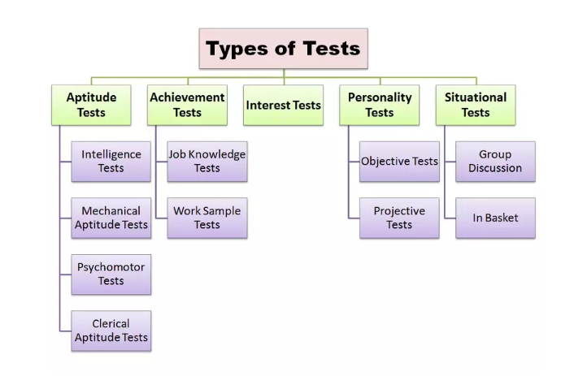

**1. Aptitude Tests:**

These tests aim at measuring if an individual has the capacity or latent ability to learn a given job, in case he is given adequate training.

**Different aptitude tests are as under:**

**(i) Intelligence Tests:**

* These tests, as evident from their name, measure intelligence quotient of the candidate.
* In detail, these tests measure capacity for comprehension reasoning, word fluency, verbal comprehension, numbers, memory and space.
* Other factors are such as digit spans forward and backward information known, comprehension, vocabulary, picture arrangement and object assembly.
* Intelligence tests comprise of the following sample learning, ability, the adaptability tests, etc.

**(ii) Mechanical Aptitude Tests:**

* To evaluate the capacities of spatial visualization, perceptual speed and knowledge of mechanical matter mechanical aptitude tests are held.
* These tests are useful when selection is to be made of apprentices, skilled, mechanical employees, technicians, etc.

**(iii) Psychomotor Tests:**

* These tests measure abilities like manual dexterity motor ability and mind and coordination of candidates.
* These tests are of great use to select semi-skilled workers for repetitive operations like packing, watch assembly.

**(iv) Clerical Aptitude Tests:**

* Specific capacities that are involved in office work are measured through this test.
* This test includes the items like spelling, computation, comprehension, copying, word measuring, etc.

**2. Achievement Tests:**

* These tests are conducted in case, it is claimed by the applicants that they know something as extraordinary; as such these tests are concerned with what one has accomplished.
* These tests are more useful to measure the value of specific achievement, when an organization wishes to employ experienced candidates.

**These tests are classified into two phases:**

**(i) Job Knowledge Tests:**

* It is the test under which a candidate is put under test in the knowledge of a particular job.
* **For example,** if a junior lecturer applies for the job of a senior lecturer in commerce, he may be tested in job knowledge, where he is asked questions about Accountancy Principles, Banking Law and Business Management etc.

**(ii) Work Sample Tests:**

* This is the second phase under which a portion of the actual work is given to the candidate, as a test and the candidate is asked to do it.
* To illustrate, in case a candidate applies for a post of lecturer in Management, he may be asked to deliver a lecture on Management Information System as a work sample test.

**3. Situational Tests:**

* This test makes evaluation of a candidate in a similar real life situation.
* The candidate is asked either to cope with the situation or solve critical situations of the job.

**It can be divided as under:**

**(i) Group Discussion:**

* As it is clear from its name that this test is administered through a group discussion approach to solve a problem under which candidates are observed in the areas of initiating, leading, proposing valuable ideas, conciliating skills, oral communicating skills, coordinating and concluding skills.

**(ii) In-Basket:**

* Situational test is administered through in-basket.
* The candidate, in this test, is supplied with actual letters, telephone and telegraphic message, reports and requirements by various officers of the organization, adequate information about the job and organization.
* The candidate is asked to take decisions on various items based on the in-basket information regarding requirements in the memoranda.

**(iii) Assessment Centers:**

* Assessment centre provides wide-ranging holistic assessment of each participant as it is a process that makes evaluation of a candidate’s potential for management on the basis of three sources viz., multiple assessment technique such as situational tests, standardized methods of making inferences and pooled judgments for multiple assessors to rate each candidate’s behavior.

**4. Interest Tests:**

* Likes and dislikes of candidates in relation to work, job, occupations, hobbies and recreational activities are determined through this test.
* The objective of this test is to find out whether a candidate is interested or disinterested in the job for which he is a candidate and to find out in which area of the job range/occupation the he is interested in.
* This test is based on the assumption that there is a high correlation between the interest of a candidate in a job and job success.

**5. Personality Tests:**

* The aim of these tests is to evaluate the whole personality of the candidate such as his emotional reactions and maturity and characteristic mood.
* They are expressed in such traits like self-confidence, tact, emotional control, optimism, decisiveness, sociability, conformity, objectivity, patience, fear, distrust, initiative, judgment, dominance or submission, impulsiveness, sympathy, integrity, stability and self-confidence.

**The personality tests are of two kinds:**

1. **Objective Tests** – Objective tests are suitable for group testing and can be scored objectively.
2. **Projective Tests** – Under this, candidates are asked to project their own interpretation of certain standard stimulus situations, basing on ambiguous pictures, figures etc., under these tests.

**INTERVIEW:**

* One of the assessment and evaluation techniques for a candidate is interview. It is a type of oral exami­nation.
* Selection interview is the next process to conduct of tests.
* Even though written tests and psy­chological tests are conducted, still one-to-one communication between individuals always remains the crucial part in selection of a candidate.
* Behavioural traits, presence of mind and psychological bearing capacity can be tested through interview.

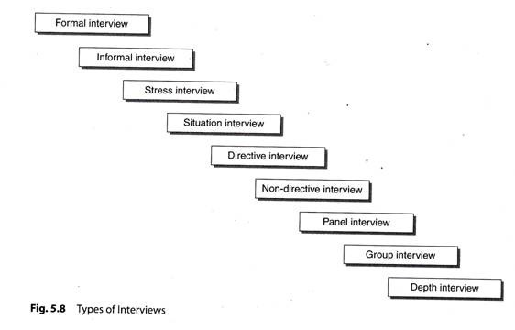**Types of Interview:**

1. **Informal interview:**

* There is no specific procedure followed in this case. They are conducted at any place, and any types of questions can be asked to the candidate.

1. **Stress Interview:**

* It is conducted to evaluate the behavior of the candidate under stressful conditions. How does a can­didate react to stress? Whether they remains quiet and calm or becomes stressed, can be judged by creating different stressful conditions around, and the case with which they gets out of it indicates their stress-handling capacity in future.

1. **Situation Interview:**

* An imaginary situation is told to the candidates and they are asked to respond to it.

1. **Directive Interview:**

* It is structured interview. A same set of questions is repeated for every candidate to make the compari­son among the answers received from them.

1. **Non-directive Interview:**

* It is non-structured interview.
* There is no specific format, and any questions can be asked to candidates.
* Candidates are free to express themselves under this type.

1. **Panel Interview:**

* A selection committee appointed for interviewing candidates is called a panel. It generally consists of three or more members who collectively perform the task of selection.
* The final decision is taken with the consent of all panel members.

1. **Group Interview:**

* Candidates are supposed to form groups, and one group together will be interviewed at one time. It is a sort of group discussion.
* The person’s ability to lead, their presence of mind and communication can be evaluated under this technique.

1. **Depth Interview:**

* All the minute details of important nature are asked to a candidate to have the extensive information about them.

**ORIENTATION:**

* **Orientation is the process of introducing new employees to their responsibilities, co-workers and workplace.**
* Effective orientation training helps people feel more comfortable within their new roles, teams and departments, while also making them aware of company expectations and policies.
* Orientation allows new hires to ask questions or address any concerns.
* It also is intended to help them feel more comfortable in their roles.
* 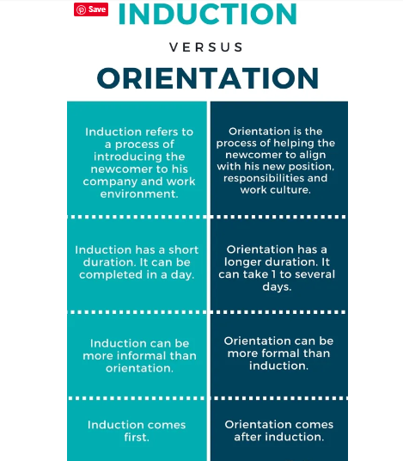Orientation is the process of introducing newly hired employees to their workplace, colleagues, job responsibilities, and organizational culture.
* It aims to help new employees feel comfortable, informed, and prepared as they begin their work within the organization.

**INDUCTION:**

* **Induction is the process of formally admitting someone to a post or an organization.**
* It is the process of introducing a new employee to the organization and vice versa.
* In this stage, the new employee learns how to become a part of the organization.

**Types of Orientation in the Selection Process:**

1. **Employee Orientation:**
   * **Formal Orientation:** A structured program that includes presentations, videos, and informational sessions to provide a comprehensive overview of the organization.
   * **Informal Orientation:** Involves informal interactions with colleagues, sharing practical insights, and addressing day-to-day aspects of the job.
2. **Job Orientation:**
   * **Task-Specific Orientation:** Focuses on the specific tasks and responsibilities associated with the new role.
   * **Skill-Based Orientation:** Emphasizes the development of specific skills required for the job.
3. **Cultural Orientation:**
   * **Organizational Culture Orientation:** Introduces employees to the values, norms, and overall culture of the organization.
   * **Team Culture Orientation:** Focuses on team dynamics, collaboration, and interpersonal relationships within the team.
4. **Socialization Orientation:**
   * **Mentorship Orientation:** Involves pairing new employees with experienced mentors to facilitate a smoother transition.
   * **Networking Orientation:** Encourages new hires to build relationships with colleagues and key individuals within the organization.

Effective orientation programs encompass a combination of these types, tailored to the specific needs and characteristics of the organization and its workforce.

**Top of Form**

* **The information provided in orientation programme usually**

**covers things like:**

1. The objectives and philosophy of the organisation.

2. Company history, policies, practices.

3. Company products and/or services.

4. Company plans and facilities.

5. Organisation structure (in general).

6. Employee responsibilities to company.

7. Company responsibilities to employee.

8. Employee compensation benefits.

9. Personnel policies.

10. Work schedules.

11. Training opportunities.

12. Safety measures and regulations.

**PLACEMENT:**

* When the candidate is selected for a particular post and when h reports to duty, the organization has to place him or her in the job for which he or she is selected which is being done through placement.
* Placement is the act of offering the job to a finally selected candidate. It is the act of finally assigning the rank and responsibility to an employee, identifying him with a particular job.

**The following principles are required to be observed while making placement of an employee:**

1. **Job requirement -** Man should be placed on the job according to the requirement of the job rather than qualification and requirement of the man.
2. **Qualification –** The job offered should match with the qualification possessed by an employee.
3. **Information –** All the information relating to the job should be given to the employees along with the prevailing working conditions. They should also be made known that they have to pay penalty for wrong doing.
4. **Loyalty and Co-operation** – Every effort should be made to develop a sense of loyalty and co-operation in employees to make them understand their responsibilities

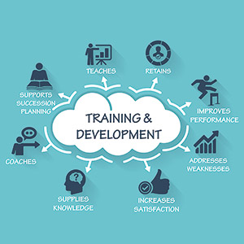

**TRAINING & DEVELOPMENT:**

**TRAINING:**

* ***Training is the process of increasing the knowledge and skills of an employee for doing a particular job.***
* It involves the development of skills that are usually necessary to perform a specific job.
* Its purpose is to bring about positive changes in-
  + 1. Knowledge,
    2. Skills, and
    3. Attitudes of the employees.
* [Training](https://getuplearn.com/blog/training-in-hrm/) is the creation of an environment where employees may acquire or learn specific, job-related behaviour, knowledge, skills, abilities and attitudes.
* Training refers to the systematic process of enhancing employees' skills, knowledge, and competencies to improve their performance in their current roles or prepare them for future responsibilities.
* Training programs are designed to develop specific job-related skills, enhance overall productivity, and contribute to the professional growth of employees within an organization.

**According to Edwin B. Hippo**

‘Training’ denotes a systematic procedure for transferring technical know- how to the employees so as to increase their knowledge and skills for doing particular jobs.

**According to Michael J. Jucious,**

“Training is any process by which the aptitude, skills and abilities of employees to perform specific jobs are increased.”

**According to Edwin Flippo**

“[Training](https://getuplearn.com/blog/training-in-hrm/#definition-of-training-in-hrm) is the act of increasing the knowledge and skills of an employee for doing a particular job”.

Top of Form

**According to Michael Armstrong**

“[Training](https://getuplearn.com/blog/training-in-hrm/#definition-of-training-in-hrm) is the formal and systematic modification of behaviour through [learning](https://getuplearn.com/blog/what-is-learning/) which occurs as a result of education, instruction, development and planned experience”.

**DEVELOPMENT:**

* Development is concerned with the growth of employees in all respects.
* It is the process by which managers or executives acquire skills and competency in their present jobs and also capabilities for future tasks.
* The purpose of development is imparting advanced knowledge and competencies among the employees.
* Development is a continuous process of building competencies of employees and thus facilitating their overall development.
* The term is generally used in relation to managers or executives and is described as ‘management development’ or ‘executive development’.
* Development involves technical skills as well as problem solving and decision making skills.
* The term development is used for executives or managers.

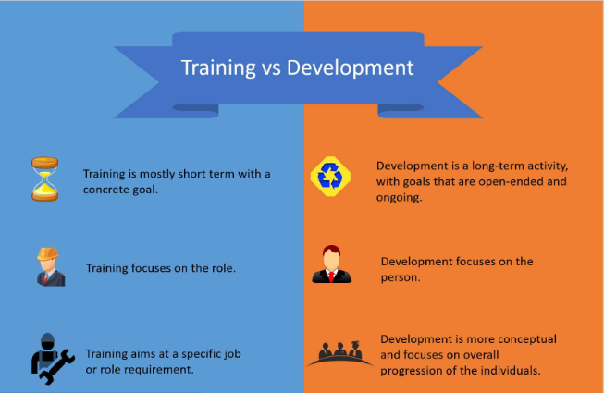

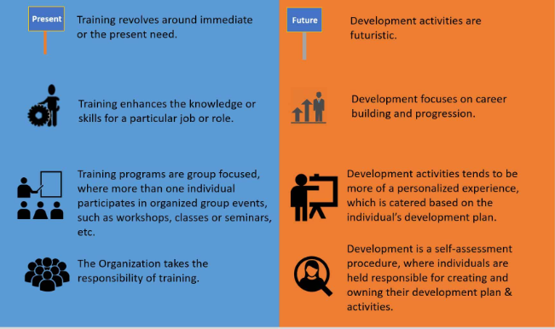

**TRAINING & DEVELOPMENT**

* Training and development refers to educational activities within a company created to enhance the knowledge and skills of employees while providing information and instruction on how to better perform specific tasks.
* Training and development programs help employees learn and acquire new skills, as well as gain the professional knowledge required to progress their careers.
* Training and development refers to educational activities within a company created to enhance the knowledge and skills of employees while providing information and instruction on how to better perform specific tasks.

**OBJECTIVES OF TRANING:**

The objectives of training are as follows:

(i) To provide job related knowledge to the workers.

(ii) To impart skills among the workers systematically so that they may learn quickly.

(iii) To bring about change in the attitudes of the workers towards fellow workers, supervisor and the organization.

(iv) To improve the productivity of the workers and the organization.

(v) To reduce the number of accidents by providing safety training to the workers,

(vi) To make the workers handle materials, machines and equipment efficiently and thus to check wastage of time and resources.

(vii) To prepare workers for promotion to higher jobs by imparting them advanced skills.

**IMPORTANCE OF TRAINING:**

* The need for training of employees arises due to the following factors:

(i) **Higher Productivity:**

It is essential to increase productivity and reduce cost of production for meeting competition in the market. Effective training can help increase productivity of workers by imparting the required skills.

(ii) **Quality Improvement:**

The customers have become quality conscious and their requirement keep on changing. To satisfy the customers, quality of products must be continuously improved through training of workers.

(iii) **Reduction of Learning Time:**

Systematic training through trained instructors is essential to reduce the training period. If the workers learn through trial and error, they will take a longer time and even may not be able to learn right methods of doing work.

(iv) **Industrial Safety:**

Trained workers can handle the machines safely. They also know the use of various safety devices in the factory. Thus, they are less prone to industrial accidents.

(iv) **Reduction of Turnover and Absenteeism:**

Training creates a feeling of confidence in the minds of the workers. It gives them a security at the workplace. As a result, labour turnover and absenteeism rates are reduced.

(vi) **Technology Update:**

Technology is changing at a fast pace. The workers must learn new techniques to make use of advance technology. Thus, training should be treated as a continuous process to update the employees in the new methods and procedures.

(vii) **Effective Management:**

Training can be used as an effective tool of planning and control. It develops skills among workers and prepares them for handling present and future jobs. It helps in reducing the costs of supervision, wastages and industrial accidents. It also helps increase productivity and quality which are the cherished goals of any modern organization.

**TRAINING METHODS-**

* There are several methods of training.
* These are mainly categorized into two groups: **On-the-Job and Off-the-Job methods.**
* **On-the-Job methods** are generally the methods that are applied to the workplace during the working of the employee. It means learning while working.
* **Off-the-Job methods** refer to the methods that are used away from the workplace. It means learning before working.

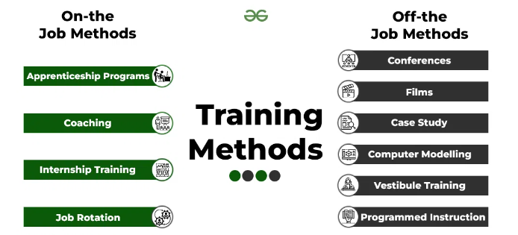

**ON-THE-JOB METHODS:**

Following are the On-The-Job methods:

1. **Apprenticeship Programs:**

* Apprenticeship programs place the trainee under the guidance of well-trained personnel.
* These programs are designed to obtain skills and knowledge of higher levels. Such programs are necessary for people entering skilled jobs, like, plumbers, electricians, etc.
* These apprentices are trainees who enter into these programs and invest some time working under the guidance of a professional or a trainer.
* The trainees are required to spend a specified time here where both fast and slow learners are trained together.
* The slow learners may be provided with additional training.

1. **Coaching:**

* In this method, the trainer who is known as the coach guides and instructs the trainee.
* The coach or the trainer sets the required goals with a mutual discussion, advises on how to achieve those goals, analyzes the trainees’ progress from time to time, and suggests changes necessary in the attitude and performance.
* The trainee works under the senior manager and the manager takes full responsibility for the employees’ training.
* The training is done to take the place of the senior manager so that he can be freed from some of his duties.
* This is also a chance for the trainee to learn about his job and the working of the organization.

1. **Internship Training:**

* Internship training is a cooperation of educational institutions and business firms.
* These trainings are generally a joint program.
* The candidates who are selected continue to pursue their studies regularly and also work in a factory or office to gain the practical knowledge and skills required for a job.

1. **Job Rotation:**

* Job rotation involves shifting trainees from one job to another or from one department to another.
* This allows the trainee to gain a better understanding of the working of the organization and all its parts.
* The rotation enables the trainee to indulge in all kinds of operations from different departments, and also allows them to enhance their knowledge and skills.
* This is also beneficial for the trainees, as they get to interact with other employees, which creates cooperation among different departments.
* Such training of employees makes it easier for the organization at the time of promotions, replacements, or transfers.

**OFF-THE-JOB METHODS**

* Following are the Off-the-Job methods:

1. **Class Room Lectures or Conferences:**

* The lecture or conference method is generally used for conveying specific information, rules, procedures, or methods.
* The use of audio-visual means makes a formal classroom presentation more interesting along with increasing the memory and proving an instrument for clearing difficulties or doubts.

1. **Films:**

* Films supply information and show a definite display of skills that are not easily represented by other techniques.
* The use of films together with conference discussion is a very effective method in most cases.

1. **Case Study:**

* Case studies are the actual experiences faced by the organization. They display the events that the managers have faced in real life.
* The trainees study these cases and analyze them sincerely to find out the problems and their causes, come up with possible solutions, select the best solution and at last, implement it.

1. **Computer Modelling:**

* It encourages the work environment by developing a computer program that copies a few of the realities of the job and enables learning to take place securely.
* It also allows the organization to see the mistakes that may occur and how much they would cost. This saves the organization from making mistakes in such situations in real life.

1. **Vestibule Training:**

* In vestibule training, the employees are given training on the equipment that they will be using during their jobs.
* Though the training is conducted away from the actual workplace, the trainees are provided with a work environment in which all the pieces of equipment, files, and materials to be used are present.
* This method is usually used when the employees need to handle advanced or complex equipment and machinery.

1. **Programmed Instruction:**

* Such a method includes a predetermined and proposed acquisition of some definite skills or general knowledge.
* In this method, the information is divided into meaningful units, and these units are arranged in a proper way to form a logical and consecutive learning bundle or collection, i.e., from simple to complex.
* The trainee is required to answer the questions asked or by filling in the blanks.

**MCQ’s:**

1. **What is recruitment?**

A) Training new employees

B) Hiring and selecting suitable candidates

C) Performance appraisal

D) Employee termination

**Answer: B**

1. **Which of the following is not a factor affecting recruitment?**

A) Economic conditions

B) Organizational culture

C) Political stability

D) Technological changes

**Answer: C**

1. **In recruitment, what is the significance of the labor market?**

A) Determines the cost of recruitment

B) Influences the availability of qualified candidates

C) Sets employee salaries

D) All of the above

**Answer: B**

1. **What is the primary objective of recruitment?**

A) Employee retention

B) Workforce planning

C) Attracting suitable candidates

D) Employee training

**Answer: C**

1. **Which of the following is an internal source of recruitment?**

A) Advertisement

B) Employee referrals

C) Job portals

D) Placement agencies

**Answer: B**

1. **What does the term 'poaching' refer to in recruitment?**

A) Hiring candidates with little experience

B) Recruiting employees from competitors

C) Selecting candidates based on personality

D) Promoting internal candidates

**Answer: B**

1. **What is the purpose of a job description in recruitment?**

A) Describing the company's history

B) Outlining the qualifications and responsibilities of a job

C) Providing employee benefits information

D) None of the above

**Answer: B**

1. **Which factor is least likely to affect recruitment?**

A) Organizational reputation

B) Employee referrals

C) Job location

D) Size of the HR department

**Answer: D**

1. **What is the significance of the recruitment process in talent acquisition?**

A) It helps in workforce planning

B) It attracts suitable candidates

C) It identifies the training needs of employees

D) All of the above

**Answer: D**

1. **What is the purpose of an employment interview in recruitment?**

A) Evaluating candidate skills and qualifications

B) Administering a personality test

C) Conducting a background check

D) Setting employee performance goals

**Answer: A**

1. **Which of the following is an external source of recruitment?**

A) Employee referrals

B) Internal job postings

C) College campus recruitment

D) Promotions

**Answer: C**

1. **What is the role of social media in modern recruitment?**

A) It has no impact on recruitment

B) It facilitates communication with employees

C) It is a source for potential candidates

D) It replaces traditional recruitment methods

**Answer: C**

1. **Which factor refers to the internal and external conditions affecting an organization's ability to recruit?**

A) Job analysis

B) Recruitment strategy

C) Recruitment environment

D) Employment branding

**Answer: C**

1. **What does the term 'headhunting' mean in recruitment?**

A) Recruiting top executives

B) Hiring entry-level employees

C) Internal job postings

D) Promoting from within

**Answer: A**

1. **Which legal factor is crucial in the recruitment process to avoid discrimination?**

A) Age discrimination

B) Employee referrals

C) Nepotism

D) Poaching

**Answer: A**

1. **What is the purpose of an aptitude test in the recruitment process?**

A) Evaluating specific job skills

B) Assessing general cognitive abilities

C) Verifying employment history

D) Conducting background checks

**Answer: B**

1. **Which of the following is a disadvantage of external recruitment?**

A) Fresh perspectives and ideas

B) Higher recruitment costs

C) Faster adaptation to company culture

D) Limited pool of qualified candidates

**Answer: B**

1. **What is the role of a recruitment agency in the hiring process?**

A) Conducting employee training

B) Conducting background checks

C) Identifying and screening candidates

D) Setting employee performance goals

**Answer: C**

1. **Which internal factor affects recruitment by providing advancement opportunities for existing employees?**

A) Compensation policies

B) Promotion policies

C) Organizational culture

D) Job analysis

**Answer: B**

1. **What is the purpose of an orientation program in the recruitment process?**

A) Evaluating candidate skills

B) Introducing new employees to the company

C) Conducting background checks

D) Setting employee performance goals

**Answer: B**

1. **Which source of recruitment is suitable for entry-level positions and internships?**

A) Employee referrals

B) College campus recruitment

C) Headhunting

D) Poaching

**Answer: B**

1. **What is the significance of employer branding in recruitment?**

A) It has no impact on recruitment

B) It influences how the organization is perceived by potential candidates

C) It is a legal requirement in the hiring process

D) It determines employee compensation

**Answer: B**

1. **What is the main goal of diversity recruitment?**

A) Increasing employee turnover

B) Fostering a work environment with varied perspectives and backgrounds

C) Reducing job satisfaction

D) Minimizing employee benefits

**Answer: B**

1. **Which of the following is an advantage of internal recruitment?**

A) Fresh perspectives and ideas

B) Higher recruitment costs

C) Shorter learning curve for new hires

D) Limited pool of qualified candidates

**Answer: C**

1. **What is the purpose of a skills inventory in the recruitment process?**

A) Evaluating candidate skills

B) Identifying skills and qualifications of existing employees

C) Conducting background checks

D) Setting employee performance goals

**Answer: B**

1. **Which method of recruitment involves attracting potential candidates by creating a positive image of the organization?**

A) Headhunting

B) Recruitment agencies

C) Employment branding

D) College campus recruitment

**Answer: C**

1. **What is the primary objective of job analysis in the recruitment process?**

A) Identifying and documenting the skills and requirements of a job

B) Conducting background checks

C) Setting employee performance goals

D) Evaluating employee benefits

**Answer: A**

1. **Which of the following is a characteristic of a good recruitment process?**

A) Lengthy and complicated application procedures

B) Lack of communication with candidates

C) Transparent and fair selection criteria

D) Limited use of technology

**Answer: C**

1. **What is the role of a job portal in the recruitment process?**

A) Conducting employee training

B) Posting job vacancies and attracting potential candidates

C) Conducting background checks

D) Setting employee performance goals

**Answer: B**

1. **Which of the following is a legal consideration in the recruitment process to ensure fair practices?**

A) Nepotism

B) Employee referrals

C) Poaching

D) Equal employment opportunity

**Answer: D**

1. **What does the term 'talent pipeline' refer to in recruitment?**

A) The process of employee termination

B) A pool of qualified candidates for future job openings

C) Employee referrals

D) Internal job postings

**Answer: B**

1. **Which external factor can affect recruitment by influencing the overall demand for a particular type of skill in the job market?**

A) Technological changes

B) Economic conditions

C) Organizational culture

D) Job location

**Answer: B**

1. **What is the significance of a realistic job preview in the recruitment process?**

A) It has no impact on recruitment

B) It provides accurate information about the job and the organization

C) It conducts background checks

D) It sets employee performance goals

**Answer: B**

1. **Which method of recruitment is based on the principle of "promoting from within"?**

A) Employee referrals

B) Internal job postings

C) Headhunting

D) Poaching

**Answer: B**

1. **What is the role of psychometric tests in the recruitment process?**

A) Evaluating specific job skills

B) Assessing general cognitive abilities and personality traits

C) Conducting background checks

D) Setting employee performance goals

**Answer: B**

1. **Which of the following is a disadvantage of using social media in recruitment?**

A) Limited reach to potential candidates

B) Lack of transparency

C) Difficulty in verifying candidate information

D) Lower recruitment costs

**Answer: C**

1. **What is the primary focus of succession planning in recruitment?**

A) Filling immediate job vacancies

B) Identifying and developing employees for future roles

C) Conducting background checks

D) Setting employee performance goals

**Answer: B**

1. **Which of the following is a common method of external recruitment for top executive positions?**

A) College campus recruitment

B) Headhunting

C) Internal job postings

D) Employee referrals

**Answer: B**

1. **What is the purpose of a probationary period in the recruitment process?**

A) Evaluating candidate skills

B) Identifying skills and qualifications of existing employees

C) Assessing employee performance before permanent placement

D) Setting employee performance goals

**Answer: C**

1. **Which legal document outlines the terms and conditions of employment and is provided to a candidate upon successful recruitment?**

A) Job description

B) Employment contract

C) Offer letter

D) Skills inventory

**Answer: C**

1. **What is the primary purpose of an employee referral program in recruitment?**

A) To discourage internal promotions

B) To reward employees for leaving the company

C) To attract potential candidates through current employees

D) To replace traditional recruitment methods

**Answer: C**

1. **Which factor refers to the degree to which a job allows an employee to complete a whole and identifiable piece of work?**

A) Job analysis

B) Job enlargement

C) Job rotation

D) Job autonomy

**Answer: D**

1. **In the context of recruitment, what does the term "culture fit" typically refer to?**

A) The organization's financial stability

B) Alignment with the company's values and work environment

C) The candidate's ethnicity and background

D) The number of years of experience a candidate has

**Answer: B**

1. **Which external factor is related to the overall conditions and trends in the economy that can impact recruitment?**

A) Organizational culture

B) Economic conditions

C) Employee referrals

D) Job location

**Answer: B**

1. **What is the significance of a realistic job preview in the recruitment process?**

A) It has no impact on recruitment

B) It provides accurate information about the job and the organization

C) It conducts background checks

D) It sets employee performance goals

**Answer: B**

1. **Which method of recruitment involves the process of moving employees horizontally within the organization to different roles?**

A) Employee referrals

B) Internal job postings

C) Job rotation

D) Headhunting

**Answer: C**

1. **What is the purpose of a talent pool in recruitment?**

A) Conducting background checks

B) Identifying and developing employees for future roles

C) Setting employee performance goals

D) Filling immediate job vacancies

**Answer: B**

1. **Which of the following is a legal consideration in the recruitment process to prevent conflicts of interest?**

A) Nepotism

B) Job rotation

C) Employee referrals

D) Internal job postings

**Answer: A**

1. **In recruitment, what does the term "on-boarding" refer to?**

A) The process of terminating an employee

B) The process of integrating and training new employees

C) The process of conducting employee referrals

D) The process of job rotation

**Answer: B**

1. **Which demographic factor is often considered in diversity recruitment efforts?**

A) Job location

B) Educational background

C) Political stability

D) Age, gender, and ethnicity

**Answer: D**

1. **What is the primary purpose of the selection process in human resource management?**

A) Employee training

B) Employee termination

C) Hiring the right candidate for a job

D) Employee motivation

**Answer: C**

1. **Which phase of the selection process involves assessing the candidate's qualifications, skills, and experience?**

A) Preliminary screening

B) Selection tests

C) Interview

D) Reference checks

**Answer: A**

1. **What is the purpose of conducting selection tests during the hiring process?**

A) To verify employment history

B) To evaluate specific job skills and knowledge

C) To conduct background checks

D) To set employee performance goals

**Answer: B**

1. **Which of the following is an example of a selection test?**

A) Company orientation

B) Aptitude test

C) Employee referral program

D) Job rotation

**Answer: B**

1. **In the context of the selection process, what is the role of an assessment center?**

A) Conducting background checks

B) Simulating job-related tasks and activities to evaluate candidates

C) Setting employee performance goals

D) Administering personality tests

**Answer: B**

1. **What type of interview involves a set of predetermined questions asked of all candidates?**

A) Unstructured interview

B) Situational interview

C) Behavioral interview

D) Structured interview

**Answer: D**

1. **Which interview technique focuses on past behavior to predict future job performance?**

A) Stress interview

B) Behavioral interview

C) Panel interview

D) Informal interview

**Answer: B**

1. **What is the purpose of a stress interview in the selection process?**

A) To assess a candidate's ability to handle pressure

B) To verify employment history

C) To conduct background checks

D) To evaluate specific job skills

**Answer: A**

1. **Which of the following is a component of the orientation process for new employees?**

A) Preliminary screening

B) Structured interview

C) Company induction

D) Selection tests

**Answer: C**

1. **What is the primary goal of an orientation program for new employees?**

A) Conducting background checks

B) Setting employee performance goals

C) Introducing employees to the organization and its policies

D) Evaluating specific job skills

**Answer: C**

1. **Which term refers to the process of assigning an employee to a specific job within the organization?**

A) Preliminary screening

B) Placement

C) Selection tests

D) Reference checks

**Answer: B**

1. **What is the purpose of a job offer in the selection process?**

A) To conduct background checks

B) To communicate terms and conditions of employment to a selected candidate

C) To evaluate specific job skills

D) To set employee performance goals

**Answer: B**

1. **Which of the following is an example of an internal selection test?**

A) Aptitude test

B) Skills inventory

C) Personality test

D) IQ test

**Answer: B**

1. **What type of interview involves a spontaneous conversation without a predetermined set of questions?**

A) Structured interview

B) Unstructured interview

C) Behavioral interview

D) Panel interview

**Answer: B**

1. **What is the purpose of conducting reference checks in the selection process?**

A) To evaluate specific job skills

B) To verify information provided by the candidate

C) To conduct background checks

D) To set employee performance goals

**Answer: B**

1. **In the context of selection, what does the term "fit" typically refer to?**

A) Physical fitness of the candidate

B) Alignment with the organization's culture and values

C) Match of educational qualifications

D) Job-specific skills

**Answer: B**

1. **Which selection test measures a candidate's ability to perform specific tasks related to the job?**

A) Aptitude test

B) Personality test

C) Skills test

D) IQ test

**Answer: C**

1. **What is the primary purpose of a panel interview in the selection process?**

A) To evaluate specific job skills

B) To conduct background checks

C) To minimize bias and ensure diverse perspectives

D) To set employee performance goals

**Answer: C**

1. **Which of the following is a disadvantage of an unstructured interview?**

A) Lack of flexibility

B) Limited exploration of candidate's qualities

C) Difficulty in replicating for different candidates

D) Standardization of questions

**Answer: B**

1. **What is the significance of a probationary period in the selection process?**

A) To evaluate specific job skills

B) To conduct background checks

C) To assess employee performance before permanent placement

D) To set employee performance goals

**Answer: C**

1. **What is the primary objective of a situational interview?**

A) To assess a candidate's problem-solving abilities in real-life scenarios

B) To evaluate specific job skills

C) To conduct background checks

D) To set employee performance goals

**Answer: A**

1. **Which term refers to the process of introducing new employees to the culture, policies, and procedures of the organization?**

A) Selection tests

B) Job rotation

C) On-boarding

D) Preliminary screening

**Answer: C**

1. **Which of the following is an advantage of using assessment centers in the selection process?**

A) Limited assessment of job-related tasks

B) Difficulty in simulating real-world scenarios

C) Comprehensive evaluation of candidates through multiple activities

D) Lack of flexibility in the assessment process

**Answer: C**

1. **What is the role of a job analysis in the selection process?**

A) Conducting background checks

B) Identifying and documenting the skills and requirements of a job

C) Setting employee performance goals

D) Administering personality tests

**Answer: B**

1. **Which of the following is a potential bias in the selection process that occurs when an interviewer forms an opinion about a candidate based on the candidate's performance in the early stages of the interview?**

A) Contrast effect

B) Halo effect

C) Similar-to-me bias

D) Recency effect

**Answer: B**

1. **What is the primary purpose of a skills inventory in the selection process?**

A) Evaluating specific job skills

B) Identifying and developing employees for future roles

C) Conducting background checks

D) Setting employee performance goals

**Answer: B**

1. **Which of the following is a potential drawback of using personality tests in the selection process?**

A) Objective assessment of a candidate's traits

B) Lack of standardization

C) Difficulty in predicting job performance

D) Limited use for certain job roles

**Answer: C**

1. **What is the purpose of a job rotation program in the selection process?**

A) Conducting background checks

B) Introducing employees to the organization's policies

C) Simulating job-related tasks and activities

D) Providing employees with advancement opportunities

**Answer: C**

1. **Which of the following is an example of an external selection test?**

A) Skills inventory

B) IQ test

C) Job rotation

D) Employee referral program

**Answer: B**

1. **What is the primary goal of a structured interview in the selection process?**

A) To evaluate specific job skills

B) To conduct background checks

C) To minimize bias and ensure fair assessment

D) To set employee performance goals

**Answer: C**

1. **What is the primary objective of training in an organization?**

A) Employee termination

B) Employee motivation

C) Enhancing employee skills and knowledge

D) Conducting background checks

**Answer: C**

1. **Which of the following is a benefit of employee training?**

A) Decreased job satisfaction

B) Increased employee turnover

C) Improved job performance

D) Limited organizational growth

**Answer: C**

1. **What does the term "skills gap" refer to in the context of training?**

A) A shortage of training programs

B) The difference between desired and actual skills in employees

C) Lack of training facilities

D) Employee resistance to training

**Answer: B**

1. **Why is the evaluation of training programs important for an organization?**

A) To discourage employee development

B) To assess the effectiveness of the training

C) To limit organizational growth

D) To reduce employee turnover

**Answer: B**

1. **Which of the following is an example of a soft skill that can be developed through training?**

A) Technical expertise

B) Time management

C) Computer programming

D) Mechanical skills

**Answer: B**

1. **What is the significance of cross-training in an organization?**

A) Reducing employee turnover

B) Enhancing employee skills in multiple areas

C) Discouraging employee development

D) Limiting organizational growth

**Answer: B**

1. **Which training method focuses on improving interpersonal skills and teamwork?**

A) On-the-job training

B) Simulations

C) Role-playing

D) Lectures

**Answer: C**

1. **How does training contribute to organizational competitiveness?**

A) By decreasing employee turnover

B) By limiting the growth of the organization

C) By enhancing employee skills and knowledge

D) By discouraging employee development

**Answer: C**

1. **What is the primary purpose of conducting a training needs assessment?**

A) To discourage employee development

B) To identify gaps between current and desired skills

C) To limit organizational growth

D) To increase employee turnover

**Answer: B**

1. **Which of the following is a disadvantage of inadequate training in an organization?**

A) Improved employee morale

B) Enhanced job performance

C) Increased likelihood of errors

D) Limited organizational growth

**Answer: C**

1. **What does the term "upskilling" mean in the context of training?**

A) Training employees for a lower-level job

B) Training employees for a higher-level job

C) Training employees for the same job

D) Eliminating training programs

**Answer: B**

1. **What is the primary goal of diversity training in an organization?**

A) Decreasing employee turnover

B) Enhancing employee skills in specific areas

C) Fostering an inclusive and respectful workplace

D) Limiting organizational growth

**Answer: C**

1. **How does training contribute to employee satisfaction?**

A) By discouraging employee development

B) By providing opportunities for skill enhancement

C) By limiting organizational growth

D) By decreasing the need for on-the-job training

**Answer: B**

1. **Which of the following is a benefit of a well-designed training program?**

A) Increased likelihood of errors

B) Decreased employee motivation

C) Improved job performance

D) Limited organizational growth

**Answer: C**

1. **What is the purpose of conducting post-training evaluations?**

A) To discourage employee development

B) To assess the effectiveness of the training program

C) To limit organizational growth

D) To decrease employee turnover

**Answer: B**

1. **What is the primary advantage of on-the-job training (OJT)?**

A) Lower cost of training

B) Reduced employee satisfaction

C) Limited flexibility

D) Employee isolation

**Answer: A**

1. **Which on-the-job training method involves pairing a new employee with a more experienced one?**

A) Job rotation

B) Coaching and mentoring

C) Simulations

D) Lectures

**Answer: B**

1. **What is the purpose of job rotation as an on-the-job training method?**

A) To discourage employee development

B) To enhance employee skills in a specific area

C) To limit organizational growth

D) To expose employees to different roles within the organization

**Answer: D**

1. **Which on-the-job training method involves moving employees from one job to another within the organization?**

A) Job rotation

B) Coaching and mentoring

C) Simulations

D) Lectures

**Answer: A**

1. **How does job instruction training (JIT) contribute to on-the-job training?**

**A) By limiting the scope of training**

**B) By discouraging employee development**

**C) By providing step-by-step instructions for a specific task**

**D) By isolating employees from the work environment**

**Answer: C**

1. **Which on-the-job training method involves employees learning by observing and imitating their peers or supervisors?**

A) Job rotation

B) Coaching and mentoring

C) Simulations

D) Modeling

**Answer: D**

1. **What is the primary disadvantage of on-the-job training (OJT)?**

A) Limited cost-effectiveness

B) Reduced employee satisfaction

C) Lack of flexibility

D) Potential for errors during training

**Answer: D**

1. **Which on-the-job training method is suitable for tasks that are repetitive and can be broken down into specific steps?**

A) Job rotation

B) Coaching and mentoring

C) Simulations

D) Job instruction training (JIT)

**Answer: D**

1. **How does coaching contribute to on-the-job training?**

A) By limiting the scope of training

B) By providing step-by-step instructions for a specific task

C) By isolating employees from the work environment

D) By offering guidance and feedback to employees

**Answer: D**

1. **What is the significance of simulations in on-the-job training?**

A) To discourage employee development

B) To enhance employee skills in a specific area

C) To limit organizational growth

D) To replicate real-world scenarios for training purposes

**Answer: D**

1. **What is the primary advantage of off-the-job training?**

A) Reduced employee satisfaction

B) Increased cost of training

C) Exposure to a variety of learning experiences

D) Limited flexibility

**Answer: C**

1. **Which off-the-job training method involves sending employees to workshops or courses conducted outside the organization?**

A) Lecture method

B) Case study

C) Role-playing

D) External seminars and conferences

**Answer: D**

1. **What is the purpose of the lecture method in off-the-job training?**

A) To limit organizational growth

B) To provide hands-on experience to employees

C) To discourage employee development

D) To convey information and concepts to a large audience

**Answer: D**

1. **Which off-the-job training method involves presenting employees with a detailed account of a real or hypothetical situation?**

A) Lecture method

B) Case study

C) Role-playing

D) In-basket exercises

**Answer: B**

1. **What is the primary disadvantage of external seminars and conferences as an off-the-job training method?**

A) Limited exposure to industry trends

B) Increased cost of training

C) Reduced employee satisfaction

D) Lack of networking opportunities

**Answer: B**

1. **Which off-the-job training method involves employees assuming a role and acting out a situation as they would in their actual job?**

A) Case study

B) Role-playing

C) In-basket exercises

D) Sensitivity training

**Answer: B**

1. **What is the purpose of sensitivity training in off-the-job training?**

A) To discourage employee development

B) To limit organizational growth

C) To enhance interpersonal skills and relationships

D) To provide technical expertise to employees

**Answer: C**

1. **Which off-the-job training method involves presenting employees with a set of job-related documents and asking them to prioritize and respond to each document as if they were on the job?**

A) Case study

B) Role-playing

C) In-basket exercises

D) Simulation exercises

**Answer: C**

1. **What is the primary advantage of role-playing as an off-the-job training method?**

A) Limited exposure to industry trends

B) Increased cost of training

C) Enhanced interpersonal skills and relationships

D) Reduced employee satisfaction

**Answer: C**

1. **Which off-the-job training method involves presenting employees with a set of job-related documents and asking them to prioritize and respond to each document as if they were on the job?**

A) Case study

B) Role-playing

C) In-basket exercises

D) Simulation exercises

**Answer: C**

1. **What is the purpose of in-basket exercises in off-the-job training?**

A) To discourage employee development

B) To limit organizational growth

C) To enhance decision-making and time management skills

D) To provide technical expertise to employees

**Answer: C**

1. **Which off-the-job training method involves employees participating in computer-based or virtual reality simulations?**

A) Case study

B) Simulation exercises

C) In-basket exercises

D) Sensitivity training

**Answer: B**

1. **What is the primary purpose of e-learning as an off-the-job training method?**

A) To discourage employee development

B) To limit organizational growth

C) To provide online training modules and resources

D) To enhance interpersonal skills and relationships

**Answer: C**

1. **Which off-the-job training method involves employees learning from instructional materials provided through an electronic medium?**

A) Case study

B) Simulation exercises

C) E-learning

D) Sensitivity training

**Answer: C**

1. **What is the significance of on-the-job training (OJT) in off-the-job training?**

A) To discourage employee development

B) To limit organizational growth

C) To provide hands-on experience within the organization

D) To enhance interpersonal skills and relationships

**Answer: C**